Life is a Highway CTF writeup

Result and scope
The user confirmed the correct starting coordinate as 39.0286785634, -77.4043945431, in the Cascades area of Sterling, Virginia. My submitted estimate was 39.0287, -77.4043. The separation between those two points is approximately 8.51 metres, well inside the challenge's 1 kilometre tolerance.
I decoded speed and yaw from the CAN capture, integrated a relative driving trace, anchored its end at the supplied location, and fitted the highway section to Virginia Route 7. This produced an estimate from vehicle motion and road geometry. The ten-decimal accepted coordinate came from the user's later confirmation; those extra digits were not extracted from the log.
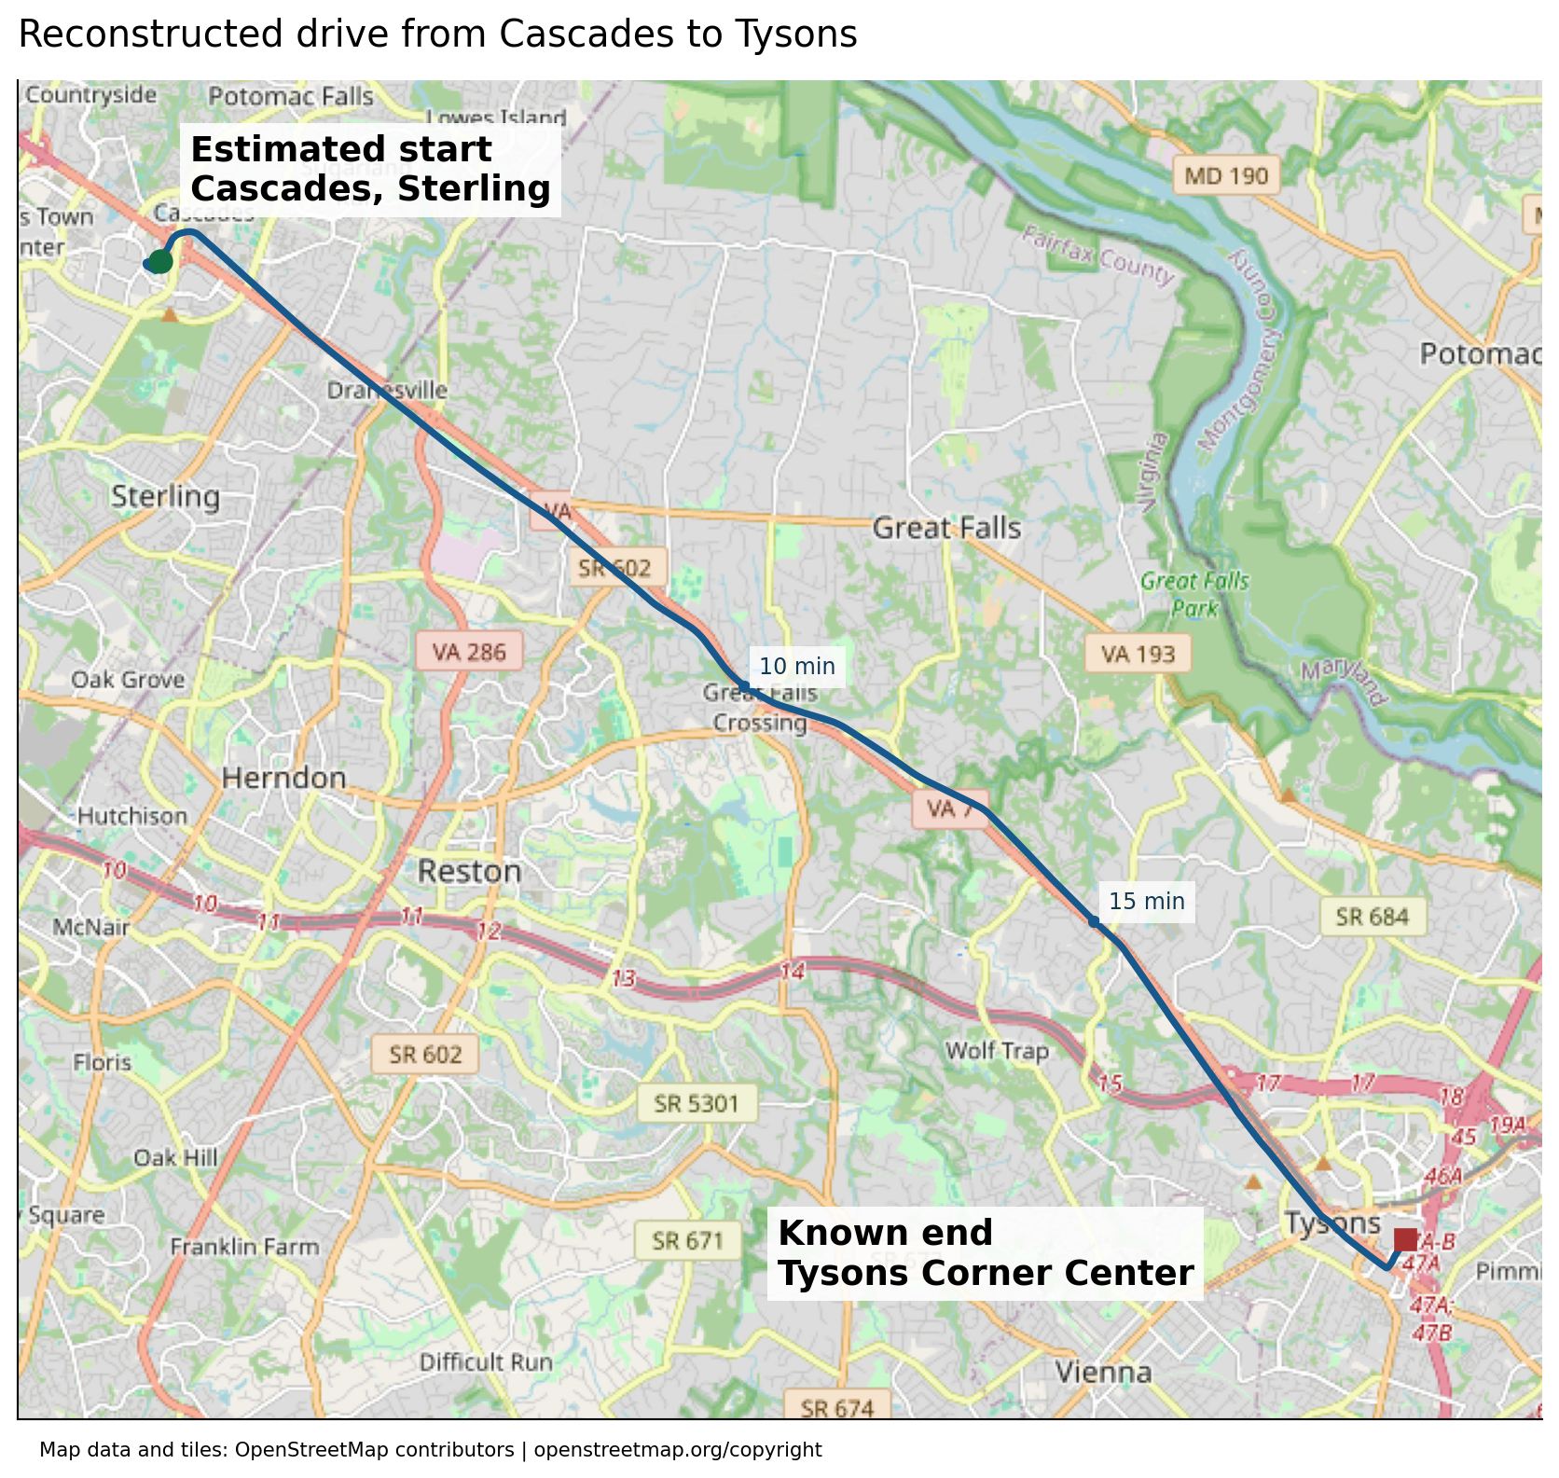
Figure 1. The fitted drive runs southeast from Cascades along Route 7 to Tysons. The polyline is the reconstructed CAN trajectory, so small deviations from mapped roads remain visible. Map data and tiles are from OpenStreetMap contributors.

Challenge material
The supplied description was titled Life is a Highway, listed 10 points and the author Veryyes, and asked where a suspect's trip began. It supplied the final position 38.9166896, -77.2210292 and stated that the car was found at the top of a parking lot. The available capture was candump-2026-08-22_185046.log.gz; the allowed answer tolerance was 1 kilometre.
The final point was essential. Speed and yaw alone describe a trajectory up to an unknown translation and rotation, with accumulated sensor error. A known endpoint fixes the translation. Recognizable roads and the final garage manoeuvres provide clues about rotation and calibration.
Input | Size or SHA256
description.txt | 021332951fb5c2c4f2c9f3a2410caf5f  4019e0b3b835ce36e3c0d6978f6b7a6c
CAN capture | 12,689,699 compressed bytes
Capture SHA256 | deb265590271624d1fa0288ab6d9171b  ae61377ba61ce8fdced9e8ae41dedf4e

The inputs in the bundle are unchanged. SHA256 hashes identify the exact bytes, so a later reader can distinguish this capture from another trip or a modified file.

Inspecting the capture
I opened the gzip stream as text, inspected the first and last records, counted arbitration IDs, and examined per-byte ranges and the number of unique payloads. There was no need to decompress the entire log to a second text file.
A typical record looked like this:
(1787439046.942595) can0 621#1100000000000000
The parenthesized value is a Unix timestamp in seconds. can0 is the interface. 621 is the hexadecimal arbitration ID, and the characters after # are the hexadecimal payload bytes. These records use the ordinary candump log representation, not decoded diagnostic parameter names.
with gzip.open(path, "rt") as stream:
for line in stream:
timestamp, interface, message = line.split()
can_id, payload_hex = message.split("#")
stamp = float(timestamp[1:-1])
payload = bytes.fromhex(payload_hex)
Capture property | Observed value
Total frames | 1,740,622
Unique arbitration IDs | 91
First timestamp | 1787439046.942595
Last timestamp | 1787440832.484552
Overall duration | 1,785.541957 seconds, or 29 minutes 45.54 seconds
Most frequent ID | 0x020, with 147,004 frames
Yaw message 0x024 | 146,978 frames
Wheel speeds 0x0AA | 147,002 frames
Vehicle speed 0x0B4 | 73,544 frames

The many repeated records at IDs such as 0x020 were not automatically useful. I concentrated on changing signals that could explain the vehicle's movement. The byte inventory and raw samples are produced by 00_inspect_capture.py; capture_inventory.json contains the complete per-ID result.

Recognizing and validating the Toyota layout
The combination of IDs 0x024, 0x025, 0x0AA, 0x0B4, and 0x260 suggested Toyota signal definitions. I checked the common Toyota definitions in commaai opendbc's _toyota_2017.dbc, then tested the decoded values against the capture. A plausible make identification was useful, but a precise model year or VIN was not necessary for the solution.
The DBC names below describe the message layout used in the analysis. I did not assume that an ID alone guaranteed a correct interpretation: zero-speed wheel values, realistic driving speeds, steering activity, and agreement between yaw and wheel differences served as cross-checks.
Hex ID | Decimal ID | DBC message | Role in the solve
0x024 | 36 | KINEMATICS | Yaw rate for changes in heading
0x025 | 37 | STEER_ANGLE_SENSOR | Supporting steering evidence
0x0AA | 170 | WHEEL_SPEEDS | Independent distance and turn checks
0x0B4 | 180 | SPEED | Main speed input
0x3BC | 956 | GEAR_PACKET | Reverse versus forward motion

The core DBC entries were:
BO_ 36 KINEMATICS: 8 XXX
SG_ YAW_RATE : 1|10@0+ (0.244,-125) ... "deg/s"
BO_ 180 SPEED: 8 XXX
SG_ SPEED : 47|16@0+ (0.01,0) ... "km/h"
BO_ 956 GEAR_PACKET: 8 XXX
SG_ GEAR : 13|6@0+ (1,0) ...
The @0 notation denotes Motorola, or big-endian, DBC bit order. The byte-level formulas in the next section avoid ambiguity about how those start bits traverse bytes.

Decoding speed yaw and gear
All payload indices in this section start at zero. If b is an eight-byte payload, b[0] is its first byte. In the saved NumPy arrays, column zero is the timestamp, so payload byte zero appears in column one. That distinction matters when reading the original scripts.

Vehicle speed
The speed is a 16-bit unsigned value in payload bytes five and six:
speed_raw = (b[5] << 8) | b[6]
speed_kph = speed_raw * 0.01
speed_ms = speed_kph / 3.6
For example, 0000000002008745 has speed bytes 00 87, giving raw 135 and speed 1.35 km/h. The final byte 45 is not part of the speed field. After decoding the entire message stream, the maximum speed was 103.97 km/h. Integrating the unsigned speed over its own timestamps gave 22.039760 km of travelled distance.
That distance is an unsigned travel-length check, before the final fitted speed scale and before giving reverse motion a negative sign. It is not the straight-line distance between the start and end.

Yaw rate
The yaw field uses the lowest two bits of byte zero followed by all eight bits of byte one:
yaw_raw = ((b[0] & 0x03) << 8) | b[1]
yaw_dbc_deg_s = yaw_raw * 0.244 - 125.0
It is an unsigned ten-bit field with an offset, rather than a signed integer. The observed raw values ranged from 359 to 641. For exploratory work and fitting, I used an algebraically convenient centered form:
yaw_centered_deg_s = (yaw_raw - 512) * 0.244
yaw_corrected_deg_s = yaw_centered_deg_s - bias_deg_s
The nominal DBC formula equals the centered formula minus 0.072 deg/s, because 512 * 0.244 - 125 = -0.072. Therefore an optimized bias near 0.07 is consistent with that parameterization. It should not be described as an additional 0.07 correction applied after the DBC offset; that would subtract the offset twice.
The centered yaw ranged from approximately -37.332 to 31.476 deg/s. Long straight segments were especially sensitive to a small constant offset. A 0.01 deg/s error accumulated for 1,000 seconds changes heading by ten degrees, enough to displace a reconstructed starting point substantially.

Wheel speeds
Each pair of bytes in 0x0AA contains a wheel speed. The common DBC defines a fault flag in the top bit and a 15-bit speed field. For one pair:
wheel_raw = ((b[i] << 8) | b[i + 1]) & 0x7FFF
wheel_kph = wheel_raw * 0.01 - 67.67
The four pairs represent front right, front left, rear right, and rear left. The payload 1A6F1A6F1A6F1A6F decodes to zero on every wheel because hexadecimal 1A6F is decimal 6767.
Distance source | Integrated distance in km
Vehicle speed 0x0B4 | 22.039760
Front right | 22.045640
Front left | 22.045986
Rear right | 21.921167
Rear left | 21.897481

The near agreement between the main speed and front wheels supported the speed decode. The rear differences also warned against treating raw wheel-speed differences as a perfectly calibrated yaw sensor.

Gear and reverse
The gear code is the lowest six bits of payload byte one in 0x3BC:
gear = b[1] & 0x3F
# DBC values: 0 D, 1 S, 8 N, 16 R, 32 P
if gear == 16:
speed_ms *= -1
The trip begins with a brief reverse manoeuvre. For position integration, reverse speed must be negative. The gyro continues to measure rotation of the vehicle body, so its measured yaw is not negated merely because the gear is reverse.

Building a synchronized relative trajectory
Messages arrived at different times and rates. I resampled speed and centered yaw onto a 0.15 second grid using linear interpolation, then assigned each grid sample the most recent gear message with searchsorted. The grid starts at the first 0x024 timestamp; all later time ranges in the fitting code are relative to that timestamp.
grid = np.arange(yaw_timestamps[0], yaw_timestamps[-1], 0.15)
speed = np.interp(grid, speed_timestamps, speed_ms)
yaw = np.interp(grid, yaw_timestamps, yaw_centered_deg_s)
gear_index = np.searchsorted(gear_timestamps, grid, side="right") - 1
I formed a motion mask using unsigned speed above 0.1 m/s, before applying the reverse sign. When that mask was false, the yaw contribution was set to zero. This avoids accumulating a quantized near-zero gyro offset during long stops. It is a practical low-speed assumption rather than a claim that every sensor sample is noiseless.
Heading is obtained by integrating angular velocity. East and north positions follow by integrating signed speed resolved along the heading. The implementation uses trapezoidal integration with the actual sample times:
heading = cumulative_trapezoid(
np.deg2rad(corrected_yaw), time, initial=0
)
east = cumulative_trapezoid(
signed_speed * np.cos(heading), time, initial=0
)
north = cumulative_trapezoid(
signed_speed * np.sin(heading), time, initial=0
)
Mathematical angles increase counterclockwise from east. A compass bearing would instead be (90 - angle_degrees) % 360. Mixing those conventions, using km/h as m/s, or passing degrees directly to sine and cosine would produce a fundamentally wrong trace.
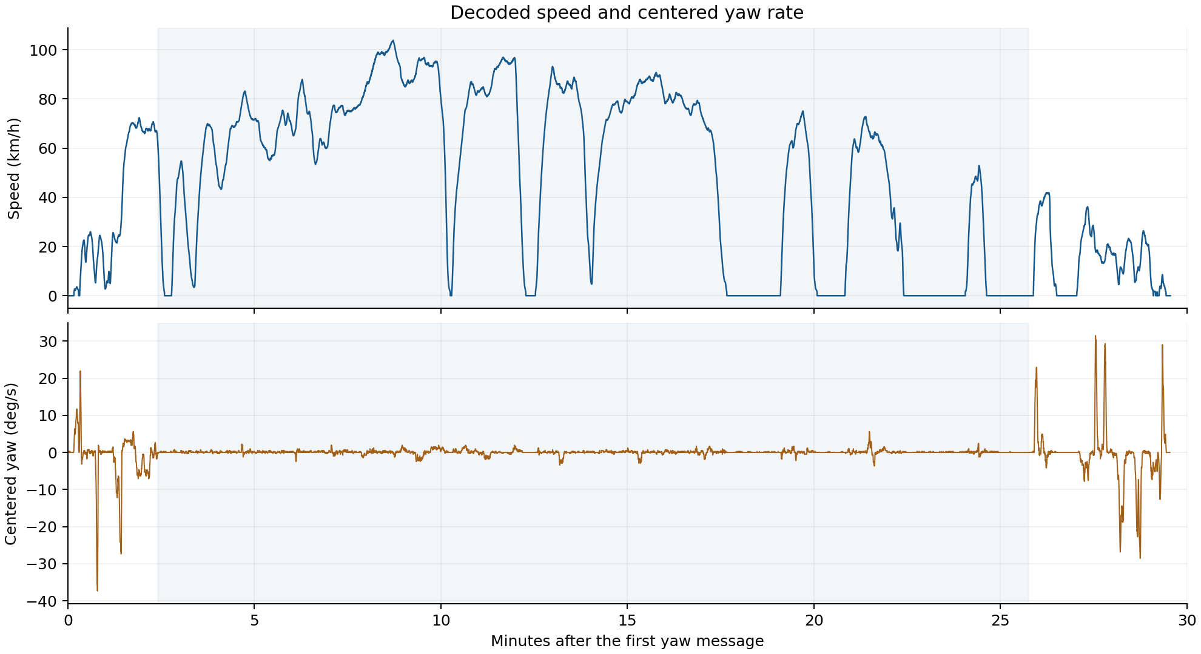
Figure 2. The speed trace shows the long fast section, multiple stops, and the slower final manoeuvres. Yaw activity is concentrated around bends and parking turns.
Initially I plotted several relative paths with no map fit. Centering the gyro at raw 512 without accounting for the remaining offset gave strongly different route shapes from paths using a small bias. Changing the yaw factor from 0.244 to 0.25 also changed the geometry. Those exploratory plots established that sensor calibration, not merely a final translation, had to be part of the solve.
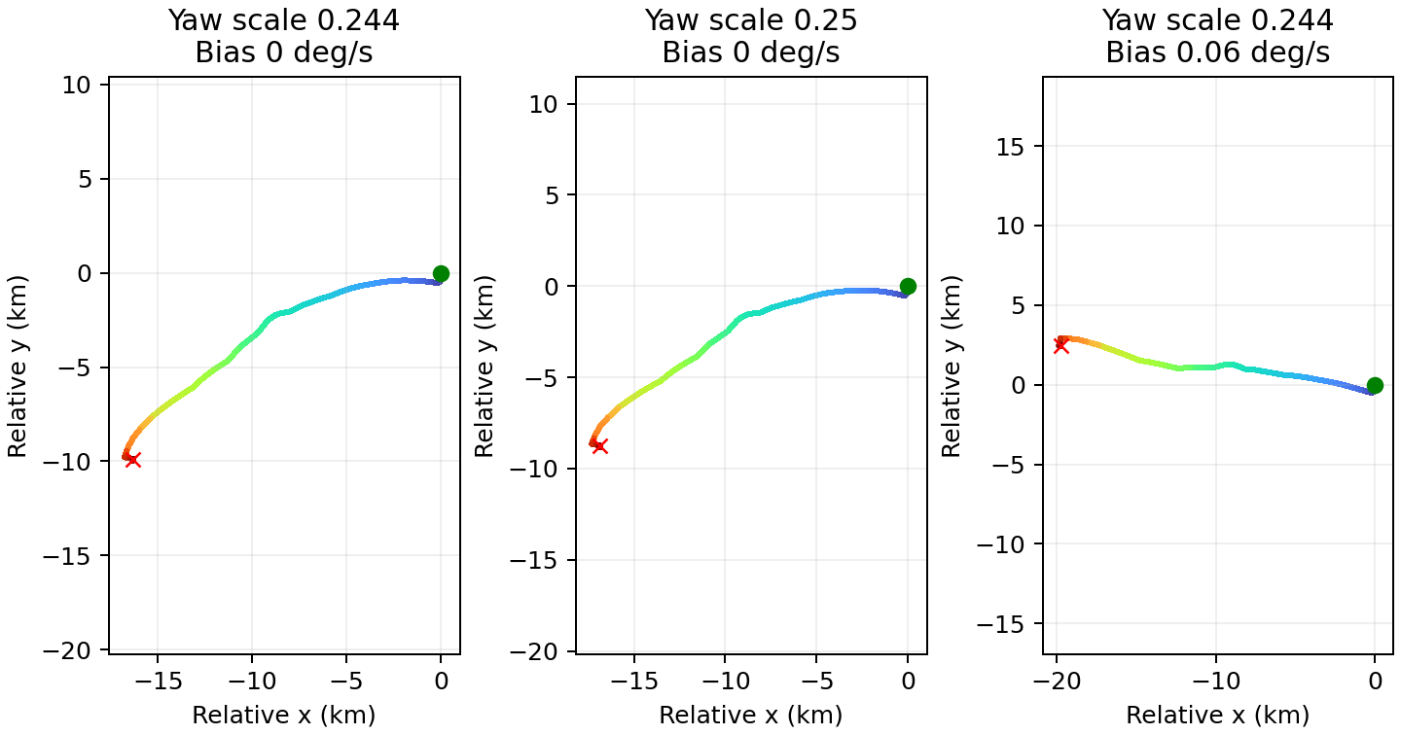
Figure 3. Early integrations use an arbitrary starting orientation. They illustrate how a small yaw-offset choice changes the inferred geometry over a long drive.

Using the endpoint and road map
The supplied endpoint lies at Tysons Corner Center's Parking Garage C in the OpenStreetMap geometry I downloaded. The final CAN section contains repeated turns and traverses consistent with parking-garage circulation. This agreed with the challenge's statement that the car was found at the top of a parking lot.
The parking geometry helped me choose an approximate orientation to explore, but it did not by itself determine a unique route. In particular, I did not assume that every interior garage aisle or every floor was represented in the map.
For a local Cartesian frame, I placed the known endpoint at the origin and used a short-range equirectangular approximation:
metres_per_lat_degree = 111111.0
metres_per_lon_degree = 111111.0 * np.cos(np.deg2rad(end_lat))
east = (longitude - end_lon) * metres_per_lon_degree
north = (latitude - end_lat) * metres_per_lat_degree
After integrating a candidate trace, I subtracted its last position from every point. This anchors the final sample at the known endpoint. Geographic output is then obtained by reversing the projection. The approximation is adequate for this regional reconstruction and 1 km tolerance, but its errors are part of why the fitted parameters should be viewed as effective calibration values.

Obtaining usable road geometry
I first tried several Overpass endpoints. The responses included HTTP 406, HTTP 502, and timeouts. Larger calls to the core OSM map endpoint exceeded its 50,000 node limit. An initial Python fetch also failed because requests was unavailable; I switched to the standard library's urllib.request.
Smaller map boxes worked. They provided enough geometry to identify the Tysons garage, inspect Route 7, and establish that the start was in the Cascades area. For a complete highway reference, the useful shortcut was retrieving route membership rather than repeatedly expanding map boxes:
https://www.openstreetmap.org/api/0.6/way/227892589/relations
https://www.openstreetmap.org/api/0.6/relation/176453/full
The first response identified relation 176453 with network=US:VA, ref=7, and route=road. The second returned its member ways and nodes. This provided a continuous Route 7 reference without pulling every building and minor street in a large bounding box.
The final regional extraction retained 313 ways, selecting primary, trunk, and motorway ways whose mean coordinate fell within latitude 38.90 to 39.06 and longitude -77.435 to -77.22. In the optimizer, a simple endpoint-eastward heuristic discarded ways whose final x coordinate was west of their first. That heuristic was sufficient for this regional eastbound route; it is not a general-purpose one-way or route-topology validator.
Reference polylines were sampled at roughly 15 metre scale, rounded to a 5 metre grid, deduplicated, and limited to points 800 metres to 20 kilometres from the endpoint. This yielded 922 reference points. The original program contains a comment saying 1 km, but its actual lower cutoff is 800 metres; the reproduction preserves the code's cutoff.
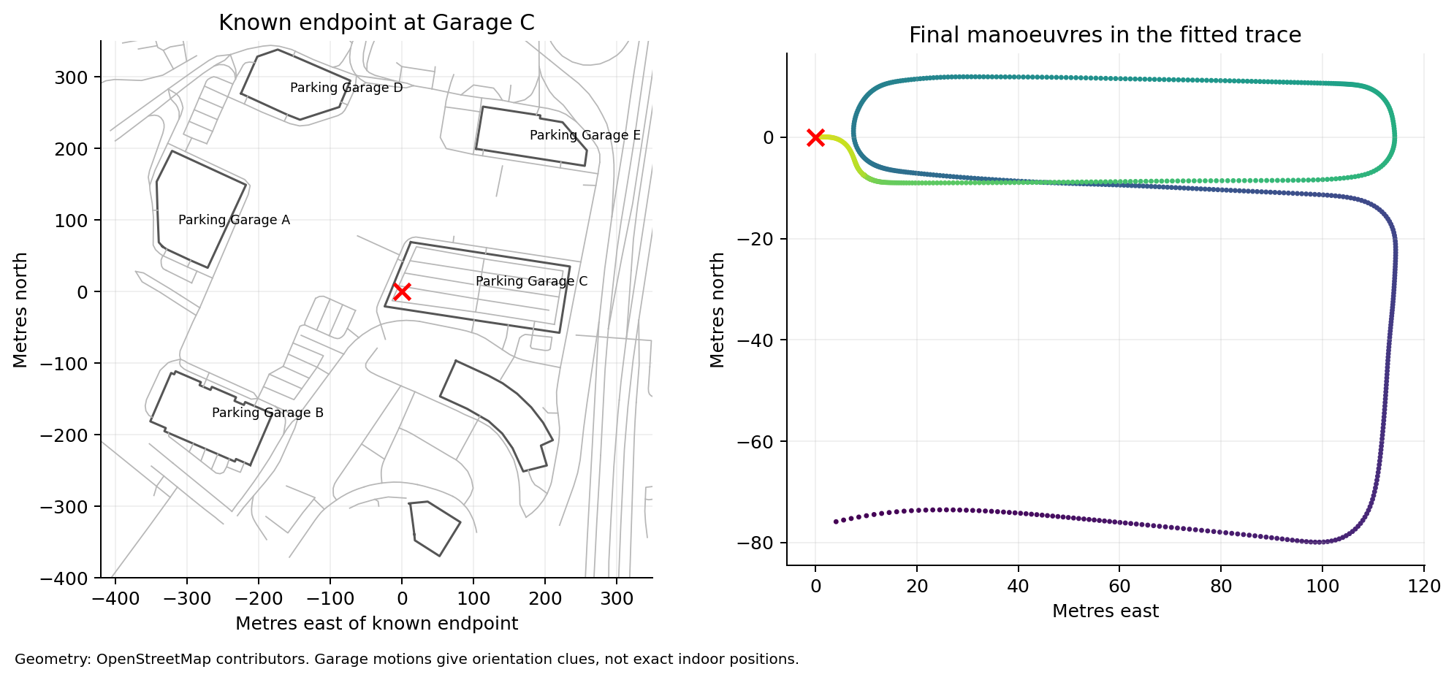
Figure 4. The known endpoint and final reconstructed manoeuvres support a garage interpretation. They do not establish exact positions on individual garage floors.

Fitting the highway trace
I optimized three quantities: a constant yaw bias, a heading parameter near the final garage section, and a speed scale. The input remained the raw capture and external road geometry. The answer later confirmed by the user was not part of this optimization.
Parameter | Search interval | Meaning
Yaw bias | 0.04 to 0.14 deg/s | Subtracted from the centered yaw signal while moving
Heading at 1735 seconds | 160 to 185 degrees | Mathematical angle counterclockwise from east
Speed scale | 0.98 to 1.02 | Multiplier on signed decoded speed

To avoid recomputing the same integrals for every candidate, I precomputed the centered yaw integral and cumulative moving time. I subtracted their values at the sample nearest 1735 seconds. This made the heading parameter refer to that late-trip sample rather than to the unknown initial orientation.
angle = (
yaw_integral_relative_to_reference
- np.deg2rad(bias) * moving_time_relative_to_reference
+ np.deg2rad(reference_heading)
)
For each candidate, I integrated the scaled signed speed with this angle, anchored the last position at zero, and considered the trajectory between 145 and 1545 seconds for road matching. That interval focuses on the highway travel and excludes most of the initial parking and final garage movements.
The objective was specifically road point to trajectory, not the reverse. I built a KD-tree of the candidate highway trajectory, queried it with each retained Route 7 reference point, capped distances at 3,000 metres, and minimized mean squared distance:
tree = cKDTree(candidate_xy[highway_mask])
distances = tree.query(road_reference_points)[0]
loss = np.mean(np.minimum(distances, 3000.0) ** 2)
I used SciPy differential evolution with seed=2, popsize=9, maxiter=100, tol=0.00001, polish=True, and one worker. The seed makes the recorded search reproducible in the documented environment. A fixed seed does not guarantee bit-for-bit agreement across every future numerical-library version.
The full-road fit returned:
Start latitude 39.02871982814972
Start longitude -77.40430815743889
Yaw bias 0.07041628058182295 deg/s
Heading at reference 180.4853612120586 degrees
Speed scale 1.0151222330144072
Road point to trace RMS 132.10971255337884 m
That heading is approximately compass bearing 269.515 degrees, because the script uses counterclockwise angles from east. The fitted bias is close to the nominal 0.072 offset in the centered-yaw parameterization. The roughly 1.5 percent speed adjustment was a fitted geometric scale, not a separately verified correction to the car's speedometer.
The 132.11 m RMS is an optimization score, not measured GPS position error and not a statistical confidence radius. The fit compares sampled mapped roads with a reconstructed trace; it does not know the actual location of every recorded frame. It also does not enforce a full road-network traversal or lane-level constraints.

Calibration checks and discarded approaches
I repeated the fit with modest model changes to see whether the inferred start was stable. These checks happened before the submitted answer. The confirmed point is used only for the post-solve comparison in the figure below.
Calibration | Start latitude | Start longitude | Road fit RMS in m
Constant bias with local refinement | 39.028718010 | -77.404304571 | 132.110
Yaw gain changed by 0.25 divided by 0.244 | 39.028854165 | -77.404216406 | 134.967
Linear bias drift allowed | 39.026971143 | -77.404519121 | 118.105

The linear-drift model obtained a lower road-distance score but drove its heading to the expanded 190 degree upper bound. More model freedom can reduce an objective without establishing a better physical reconstruction. I retained the simpler constant-bias result. The most different start among these variants was about 200 metres from the main estimate, which supported the original region estimate but did not constitute a rigorous 200 metre uncertainty bound.
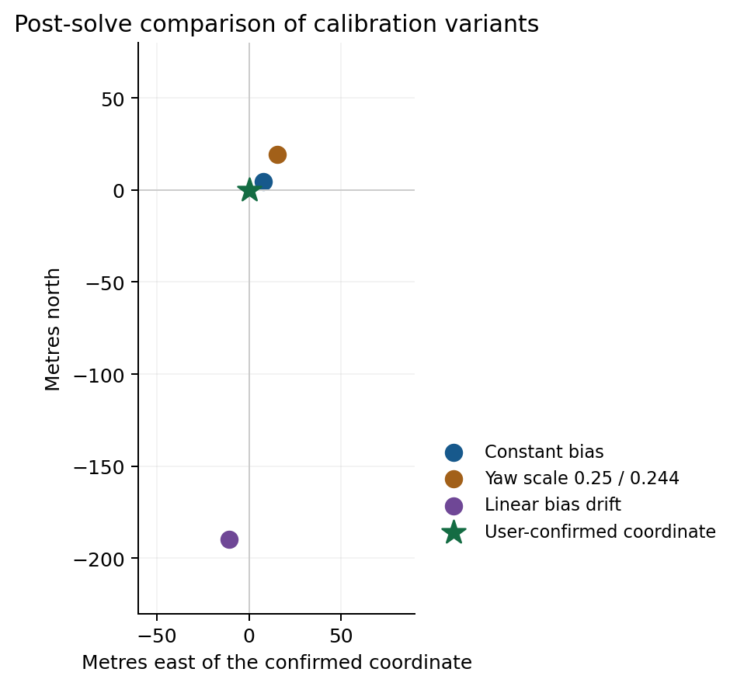
Figure 5. Positions are shown relative to the coordinate the user confirmed after the solve. The original calibration checks did not have that reference point available.

Wheel differential and lateral acceleration
As a sign and motion check, I compared yaw with the rear-right minus rear-left wheel speed during strong turns. Their correlation was 0.994585. A regression of centered yaw against rear speed difference, mean rear speed, and a constant produced coefficients approximately 37.1343, -0.0233533, -0.129092. This supported the turn direction and signal interpretation.
I did not make that wheel regression the final dead-reckoning model. Different speed selections gave inconsistent apparent track-width estimates, and small rolling-radius differences accumulate over kilometres. An exploratory 1.53 m track assumption was only a diagnostic guess, not a verified specification used in the answer. I also tried comparing lateral acceleration divided by speed with gyro yaw; the speed-dependent results were not stable enough to replace the yaw model. Road banking, tilt, offsets, and motion transients are possible confounders in that comparison.

A misleading local parking fit
A distance-only fit of the final approach to nearby drivable map lines returned a rotation near 245.02 degrees and an apparently attractive 9.91 m RMS. Visual inspection showed that this local solution did not give a plausible garage traversal. This was a useful warning: matching a short path to nearby lines is ambiguous, especially around buildings and stacked parking floors. That rotation was discarded.

The separate starting-area experiment
The original fit_start.py attempted another local alignment of the early trace to roads near Cascades. It returned approximately 39.031501443, -77.406571948, with an RMS near 59.04 m and rotation -29.75 degrees, close to the allowed -30 degree boundary. That was an exploratory result from an earlier global-fit snapshot, not the submitted coordinate. Local road proximity and a lower local score did not outweigh the whole-trip reconstruction.
The unchanged script and its saved output are included so this experiment is visible rather than silently removed. Its saved input state predated the final full-road fit; a rerun against the final snapshot can therefore differ from that historical local result.

Reproducing the result
The bundled reproduction uses Python, NumPy, SciPy, Matplotlib, and Pillow. The recorded environment was Python 3.12.14, NumPy 2.3.5, SciPy 1.17.0, Matplotlib 3.10.8, and Pillow 12.3.0. The final numerical path does not require cantools, a GPS decoder, an online route service, or a live Overpass instance.
From the extracted bundle directory:
python -m venv .venv
# Activate the environment as described in README.md
python -m pip install -r requirements.txt
python run_all.py
The ordered stages are:
Script | Output or purpose
00_inspect_capture.py | Frame inventory, ID counts, payload ranges and input hashes
01_extract_signals.py | Timestamped byte arrays, gear series and decoded signal statistics
02_reconstruct_relative.py | Early integrations and yaw-offset comparison
03_prepare_road_geometry.py | The 313 regional Route 7 ways from the frozen relation
04_fit_route.py | Final three-parameter fit, coordinates and full route CSV
05_check_calibration.py | Constant, alternate-gain and linear-drift sensitivity checks
06_make_figures.py | Report figures from the reproduced results
07_fetch_reference_data.py | Optional live reference refresh into a separate folder
08_probe_wheel_model.py | Independent wheel and yaw cross-check
09_validate_confirmed_coordinate.py | Post-solve distance comparison with the user's answer
common.py | Shared parsing, projection, integration and fitting functions
run_all.py | Ordered offline runner for the main workflow

The runner calls validation before figure generation and skips the optional network refresh. output/fitted_route.csv contains the reconstructed latitude and longitude at each 0.15 second sample. fit_result.json, calibration_variants.json, postsolve_validation.json, and verification.json make the main results easy to inspect without parsing terminal output.
For the original final optimizer, enter session_archive/ and run python fit_analysis.py, followed by python check_variants.py. Those files are preserved unchanged. SCRIPTS.md collects their full source and all reproduction scripts in one file. session_archive/inline_exploration.py is explicitly labeled as a writeup-time reorganization of inline exploratory code, rather than an original saved program.

What was verified for this package
I ran the complete offline pipeline from the included capture. The extracted signal arrays, final road-reference geometry, fitted parameters, and final trajectory arrays were identical to the original session's saved arrays in the documented environment. All packaged Python files were compiled for syntax validation. The optimizer reported successful termination.
The reproduced full-road estimate is approximately 8.76 metres from the confirmed coordinate. The rounded coordinate I originally gave is approximately 8.51 metres away. These are post-solve comparisons, computed with the haversine formula, and are distinct from the road-fitting RMS and calibration variation.

Sources and limits
The challenge description and CAN capture supplied the task, endpoint, raw measurements, and tolerance. Toyota signal definitions came from the frozen copy of commaai opendbc's common Toyota DBC. Road geometry and the regional map tiles came from OpenStreetMap. The complete reference responses used for the final fit are bundled, so later edits to online maps do not change the documented replay.
The map snapshots were retrieved during this solve and are not an archival reconstruction of the exact road map on the capture date. The accepted starting point confirms that the answer was sufficient for the challenge; it does not prove that the entire reconstructed route is exact to metres or that the model recovered physical sensor calibration uniquely.
The key to the solve was combining three constraints: a plausible decoded motion trace, a fixed endpoint, and the geometry of the highway travelled. The final point was an inference from that combination. The user confirmation established which coordinate was accepted.
Reference | URL
Common Toyota DBC | https://raw.githubusercontent.com/commaai/opendbc/master/opendbc/dbc/generator/toyota/_toyota_2017.dbc
opendbc project | https://github.com/commaai/opendbc
Route 7 relation | https://www.openstreetmap.org/relation/176453
Route 7 full API response | https://www.openstreetmap.org/api/0.6/relation/176453/full
OpenStreetMap attribution | https://www.openstreetmap.org/copyright

The full script source follows separately in SCRIPTS.md and the individual Python files. The archive notes retain failed service requests, intermediate fits, and discarded experiments alongside the successful method.

